ATM ON US FLOW

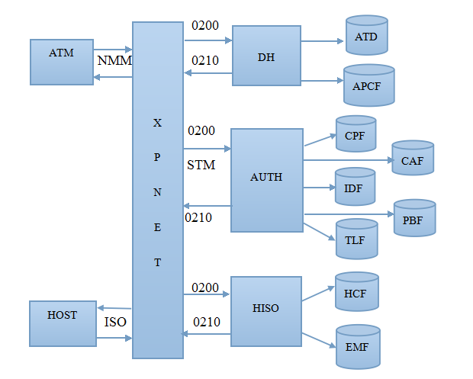

- The ATM sends a native-mode request message to the Device Handler process through XPNET.
It consists of
- Card Number
- Track 2
- Opcode
- Amount
- Pin block
- Transaction type
- Terminal id

- DH
- The ATM sends the request to DH and sets the timer to check whether the response received is within the time or not.
- The DH converts the NMM messages received from ATM to STM.
- It reads the ATD file by using terminal id as a pri key:-
- ATD gives AUTH process name, other than that it shows hardware type, location, state, owner name on page no 1.
- It checks whether the transaction received from particular terminal is valid terminal or not.
- It shows the hoppers count on page no 4 and 5.
- On page 2 we get Acquirer transaction profile name.
- Page 6 shows terminal activity information.
- By using Acquirer transaction profile name DH reads the APCF file:-
- APCF file maps the trancode.
- On page 2 it checks whether particular transaction is allowed for particular terminal or not.
- Page 3 of APCF enables to load and unload multiple records simultaneously.
- By using AUTH process name the DH sends the request message to particular AUTH
via XPNET and sets the timer.

- AUTH
- DH sends the request message 0200 to AUTH.
- The AUTH first reads the CPF file. The prikey used to read CPF file is Prefix Filed
(BIN) and PAN length. From CPF file we get,
- On page 1 we get FIID if it is on-us transaction and prefix routing.
- Page 2 contains Pin verification information and Card verification information, check if host is online.
- Page 3 verify the expiration date comparison, card validation period.
- Page 4 gives card activity limits.
- By using FIID as a prikey, AUTH reads the IDF file which gives,
- Path for CAF and PDF on page 1.
- On page 2 prescreening checks are made before sending the transaction to host. Checks if host is online, maximum pin tries, expiration date verification, bad pin action.
- On screen 9 we get ATM routing table. By using prefix routing and account type match in the routing table the transaction is route to respective HISO by using DPC no and HISO process name of respective match.
- On page 16 we get POS routing table.
- Page 19 shows acquirer transaction profile name and issuer transaction profile name for POS.
- If the host is offline the BASE 24 approves the transaction hence it checks the CAF
and PBF file.
- By using FIID and PAN as prikey the AUTH reads the CAF file,
- On page 1 of CAF it shows activity limits for individual card holder i.e card status, cash withdrawal limits.
- Page 2 allows to set expiration date for individual card. It displays bad pin tries, date first used and last used date.
- Page 3 & 4 shows multiple account for individual card holder.
- Page 7 allows to set expiration date and shows card status for second card.
- Page10 shows the POS cardholder limits i.e cash withdrawal, offline purchase, refund and replenishment.

- PBF file displays various balance and amount. The prikey used for PBF are FIID,
account type and account number
- Page 1 keeps track of account balance. It shows last withdrawal date and amount, last deposit date and amount. Available balance and card status.
- While response time the PBF, CPF, and CAF files are updated along with TLF. All
transaction occurs at BASE 24 are logged in TLF file.
- TLF logs the record in two format, terminal ID and PAN format. It displays trans code,
transaction time and date, amount with respect to its particular terminal id or pan
format.

- HISO
- AUTH send the request message to respective HISO obtained in routing table from
IDF file.
- By using HISO process name and DPC no as prikey HISO reads the HCF file. From
HCF file we get,
- Page 1 displays timer limits for network management, store and forward, wait for traffic. It also displays processing flags, maximum SAF retry and data prefix characters.
- Page 2 displays Station name associated with each DPC no. Station is a physical point in BASE 24 system that is designated to send and receive messages.
- Page 5 shows processing parameters and timer limits for ATM messages (i.e inbound and outbound limit, completion time and completion acknowledge).
- Page 7 shows timer limits for POS message (i.e inbound and outbound messages, completion timer and acknowledge).
- HISO then reads the EMF file. The prikey for EMF are interface type, DPC no,
Process name, message type, IN/OUT. The EMF file shows,
- Page 1 allows to specify which data elements are to be included while sending and receiving external messages.

- By using station name HISO sends the request to HOST and sets the timer. The
messages send by HISO are in ISO format.
- HOST then sends the response to HISO which is in ISO format. The HISO first checks
the response is within the time if yes, then it sends the response to respective AUTH.
- AUTH then updates the TLF file. Along with TLF it updates the CAF and CPF limits
and updates PBF and IDF file.
- The AUTH sends the response message to DH. The DH checks if the timer if the
response is within the time. DH then updates the ATD files hoppers count. It then
sends the response to ATM.
- ATM then checks the timer if response is within the time and completes the
transaction successfully.
- ATM then sends the response message to DH which tells it has successfully completed
the transaction and is ready for next transaction.

